**MEETING MINUTES: SUMO DIGITAL GROUP PROJECT**

**Date of meeting:** 18/02/2019

**Time of meetin**g: 12:00 PM

**Attendees**: Dragos Liche, Dawid Hojka and Alex Butler

**Mid-sprint review:**

Most of the tasks we have set out for this sprint were completed over the duration of the week, however there are still a few that need to be completed. However, we do feel like we are on track with the game currently.

Some of the tasks we set out for this sprint took more time than anticipated, so in the next sprint we will need to make sure that the tasks we set out can actually be completed in the given time. We also did have a small communication issue regarding Anthony, as he has not informed us that he will not be able to make it to the meeting today, however we found out why he didn’t show up and we informed him that he should let us know whether he can attend before the meeting starts, rather than during.

**Tasks that are yet to be completed:**

* **Dragos:** *All tasks completed for now.*
* **Dawid:**  Come up with more character designs.
* **Anthony:** Continue researching enemy pathfinding and NavMeshes.
* **Alex:** Finish the 3D models (mostly requires some touch-ups, along with UV-unwrapping, and potential texture work.)

**Meeting ended:** 12:40 PM

**Minute taker:** Dawid Hojka

**Discord Discussion Documentation:**

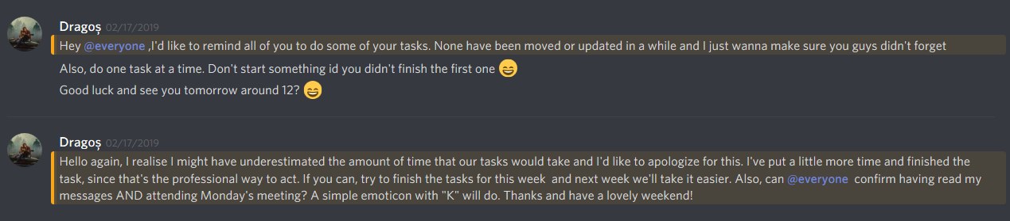

Screenshot 1 - Dragos reminding us to update the tasks on JIRA as well as asking whether we will be able to meet up next day.

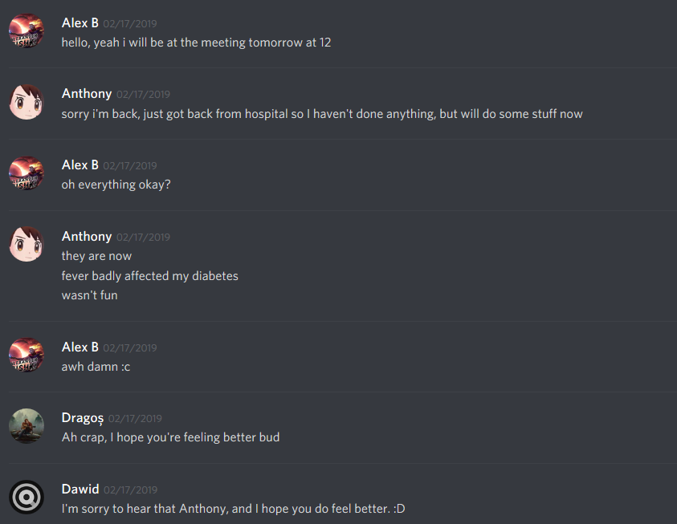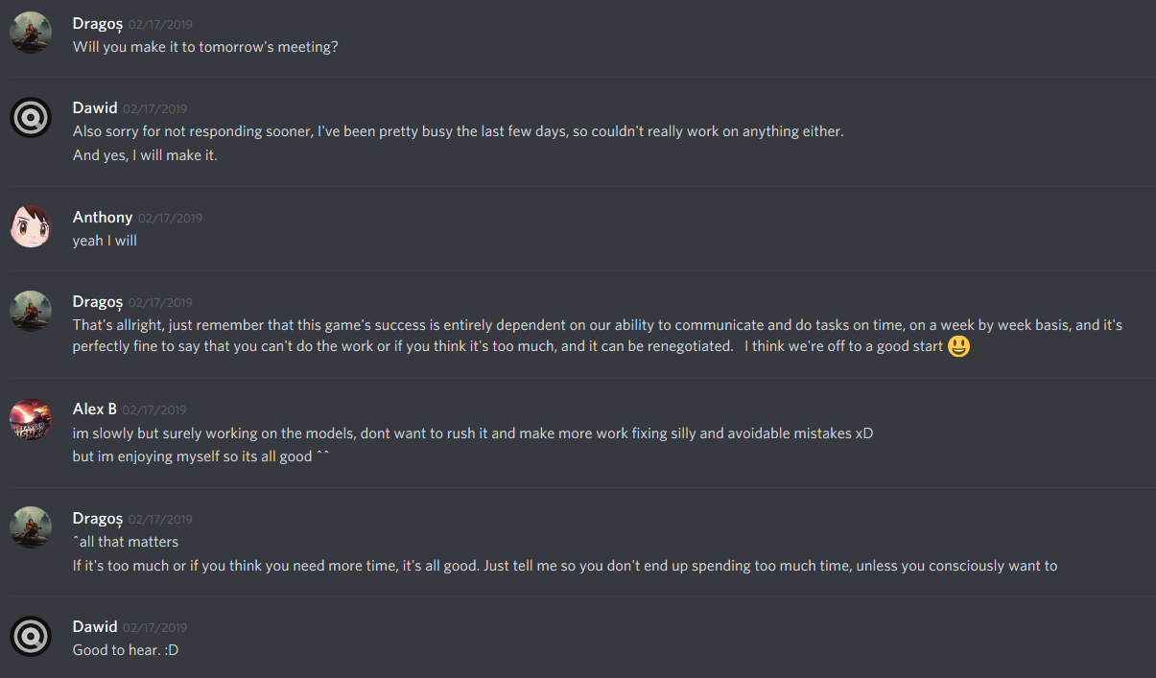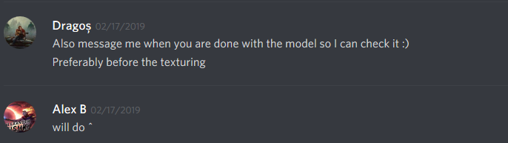

Screenshots 2 - 4 – Discussing the tasks and the upcoming meeting.

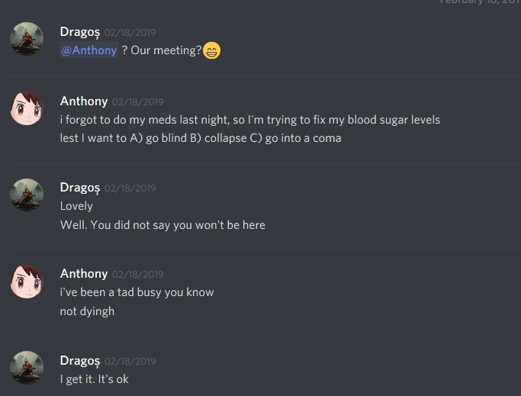

Screenshot 5 – Dragos asking Anthony about his whereabouts, since he wasn’t on the meeting despite saying he would make it.